**Database Management System - Assignments**

**Session 1**

**Assignment 1**

There is an Organization (StoreFront) that would like to go online for selling their products. We have the following information to build an application that meets the requirements:

* Application contains many Products.
* Categories will categorised the Products.
* Categories can be nested.
* A Product can fall into multiple Categories.
* A Product can have one or more Images.
* User can be a Shopper or Administrator.
* Shopper can place an order having one or more products.
* Shopper can shop only those products which are in stock.
* Shopper can have multiple Shipping Addresses.
* Independent items in an Order can be shipped, cancelled or returned.

1. Identify the participating entities.

- Category

- Order

- Sub Category

- User

- Products

1. Identify the relations.

one-to-many (1-M) :-



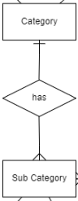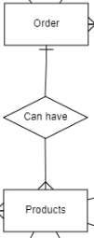

many-to-many (M-M):-



1. Identify the key attributes.

- User ID

- Order ID

- Product ID

1. Draw the E-R diagram for the problem.

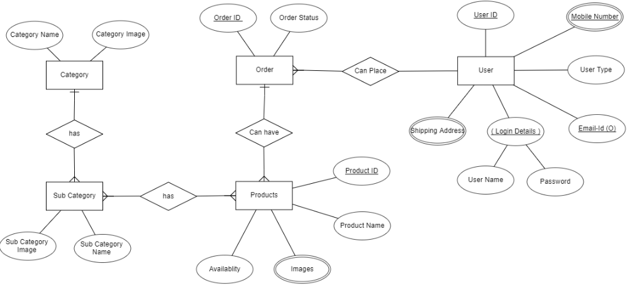

**Assignment 2**

* Explain Normalization techniques (along with an example) as discussed during Session.

Normalization is the process of organizing data in a database.

This includes creating tables and establishing relationships between those tables

according to rules designed both to protect the data and to make the database more flexible by eliminating redundancy and inconsistent dependency.

4 types of Nf

1. 1NF

2. 2NF

3. 3NF

4. BCNF( Boyce Codd Normal Form)

1. 1NF: FIRSH FORM OF NORMALIZTION FORM:

* REDUCE GROUP OF REPEATING DATA

* EACH DATA HAS A PRIMARY KEY

* First normal form disallows the multi-valued attribute, composite attribute, and their combinations.

2. 2NF: SECOND NORMALIZATION FORM

*Eliminate redundant data

*Foriegn KEY

3. 3NF : Third NORMALIZATION FORM

*Eliminate fields that do not depend on the key.

4.BCNF:Boyce Codd Normal Form

EXAMPLE:

Unnormalized table:

TABLE 1

Student# Advisor Adv-Room Class1 Class2 Class3

1022 Jones 412 101-07 143-01 159-02

4123 Smith 216 201-01 211-02 214-01

1. 1nf

Student# Advisor Adv-Room Class#

1022 Jones 412 101-07

1022 Jones 412 143-01

1022 Jones 412 159-02

4123 Smith 216 201-01

4123 Smith 216 211-02

4123 Smith 216 214-01

2. 2NF

Students:

TABLE 3

Student# Advisor Adv-Room

1022 Jones 412

4123 Smith 216

TABLE 4

Student# Class#

1022 101-07

1022 143-01

1022 159-02

4123 201-01

4123 211-02

4123 214-01

3. 3NF

Table 5

Student# Advisor

1022 Jones

4123 Smith

Faculty:

TABLE 6

Name Room Dept

Jones 412 42

Smith 216 42